LOW CARB TARTER SAUCE
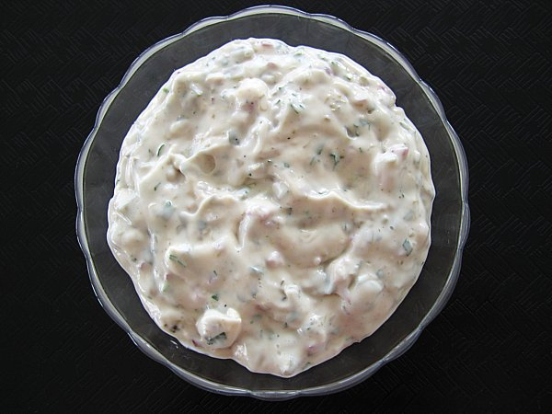
Ingredients:
Sugar Free Sweet Relish
Light Mayonnaise or Light Miracle Whip

Mix together 1 TBS of Relish and 1 TBS of Mayonnaise or Miracle Whip
Adjust to taste
Serving size 2 Teaspoons (1 gram of carbs)

Substitute Low Carb Flat Bread for hot dog or hamburger roll
Cut Flat Bread into 4 rectangle pieces
¼ piece of Flat bread = 5 grams of carbs

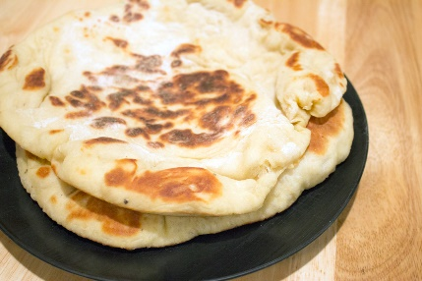
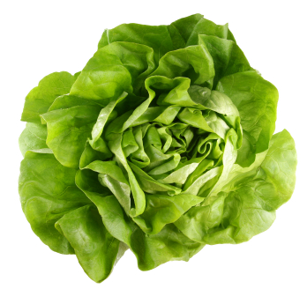
Substitute Lettuce for the Hamburger Roll (0 carbs)

