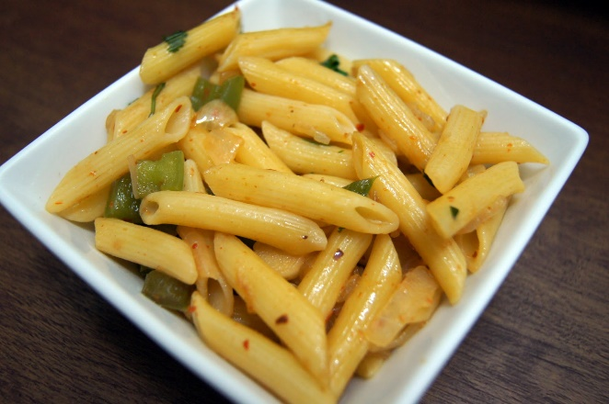
PASTA SALAD
Ingredients:
2 Bags of Frozen Birds Eye Veggie Penne in Olive Oil
½ Cup of chopped celery
1/8 Cup of Red onion
1/3 Cup of sliced Black Olives
½ Cup of Light Mayonnaise or Light Miracle Whip

Directions:
Microwave Veggie Pasta (follow directions on bag)
Empty both bags of pasta into a bowl and put in the refrigerator to chill
When chilled, Add celery, onions, black olives
Salt & Pepper to taste
Mix Together
Add Mayonnaise or Miracle Whip
Mix Well
Keep chilled
Enjoy!

Makes 5 servings (25 grams of carbs per serving)

